

**TDS3401 Project**

**SECTION: TC01/TT3V**

**TRIMESTER 2 2020/2021**

**Games Publishers of the Years**

**Lecturer: Dr. Noramiza Binti Hashim**

**Prepared By**

|  |  |
| --- | --- |
| **Student ID** | **Student Name** |
| 1171200748 | Lee Wang Lin |
| 1171201466 | Cheok Jia Heng |
| 1161204459 | Lee Xi Jie |

Contents

Description of Final Interactive Visualization 3

Storyboard 5

Explanation of changes in the implementation 11

Development Process 12

Reference 13

# Description of Final Interactive Visualization

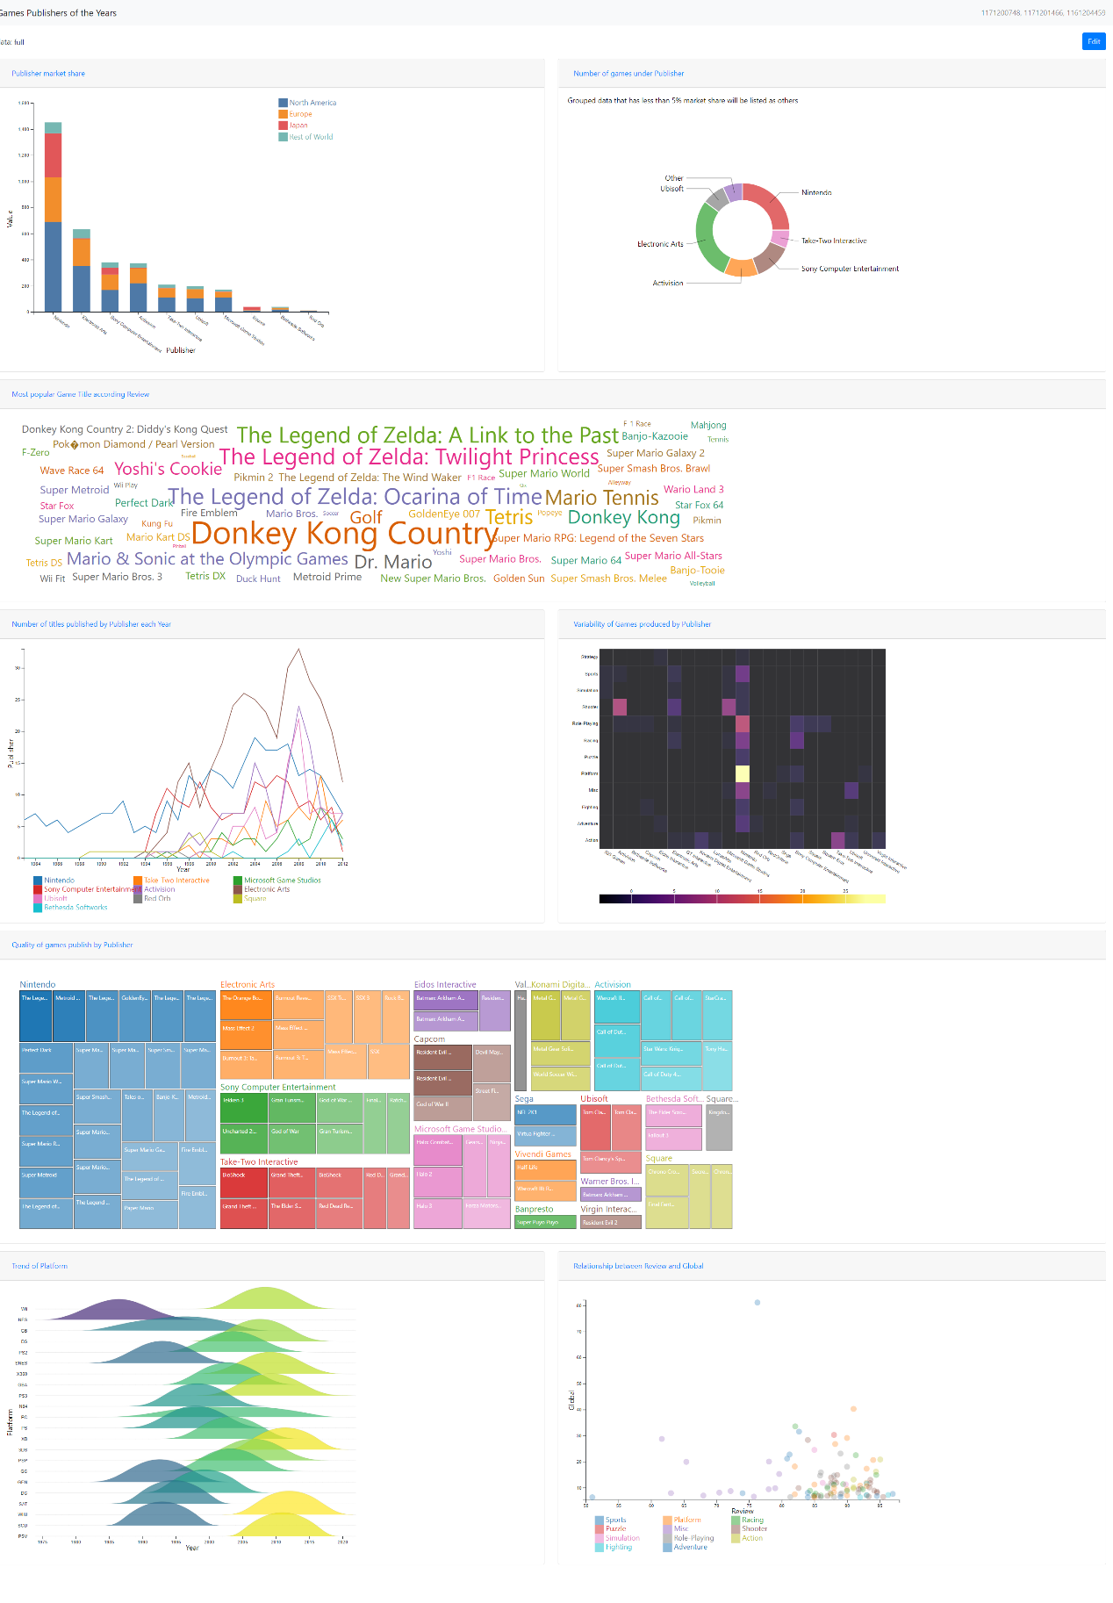

Figure 1-1 Dashboard

The final interactive visualization application consists of one vertical stacked bar chart, one donut chart, one word cloud, one line chart, one heat map, one tree map, one rigid plot and one scatter plot. The theme of the dashboard is to use the white background and plot these graphs with bright colors to attract the audience's attention. Our project title Game Publishers of the years which is located in the top left corner and followed by our student ID which is located in the top right corner. Besides in each of the graphs, we allowed the user to do the intended analysis by manually changing the input they like to. Hence most of the graphs will change to different results based on the dynamic input given by the user.

# Storyboard

In our storyboard, there are eight visualizations that we have created after studying the dataset we obtained from the data world [1]. In this visualization, it has generated the metrics for us to figure out who is the most famous publishers over the years and the intended details such as the game titles produced by the publishers, numbers of games published over the years, sales among the regions, relationship between the genre and the publishers and relationship between review versus sales etc.

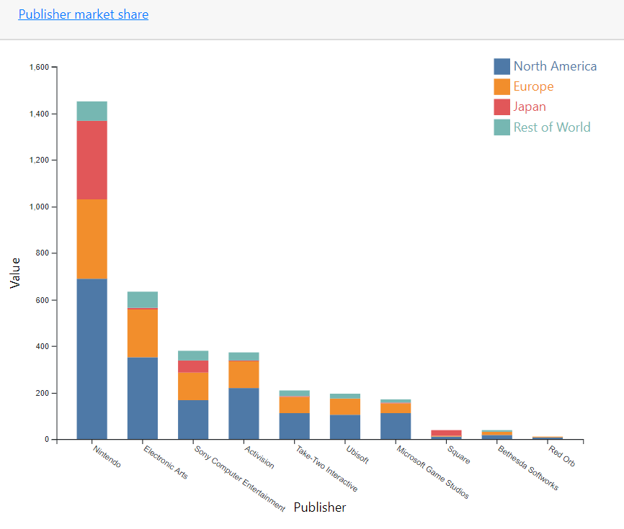

Figure 2-1 Publisher market sales

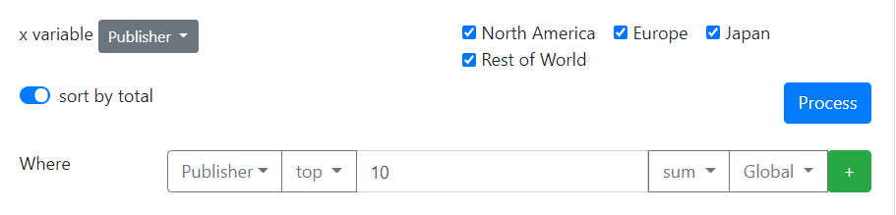

Figure 2-2 Dynamic Input

First and foremost, by plotting the stacked bar chart, we can analyze and figure out the sales of the publisher among the regions. The purpose we used the stacked bar chart is to differentiate among the regions that we can clearly compare among the regions where have the most sales from the publishers. Besides, we are allowed to give the input to do more analysis from the graph as shown in Figure 2-2. In Figure 2-1, we have shown the Top 10 of the publishers based on their global sales. From this visualization, we obtained that Nintendo has generated the most sales compared to other publishers among the years.

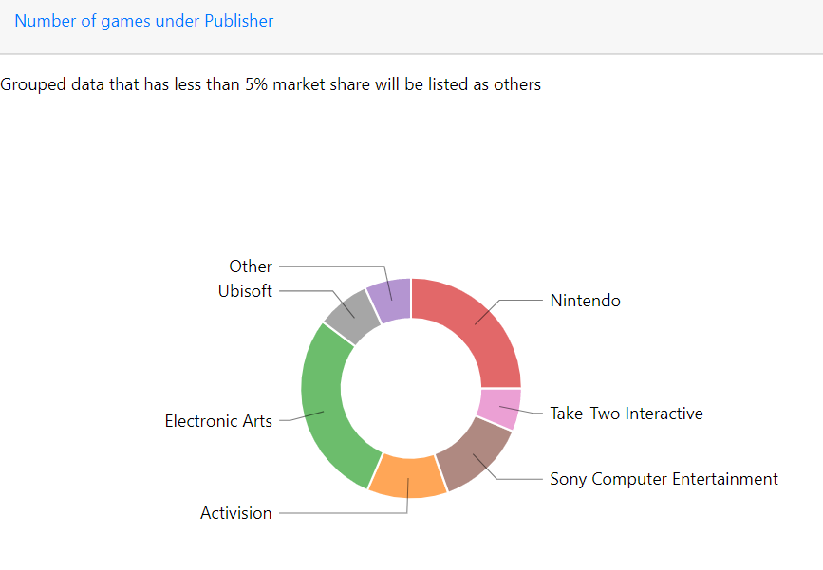

Figure 2-3 Number of games under Publishers

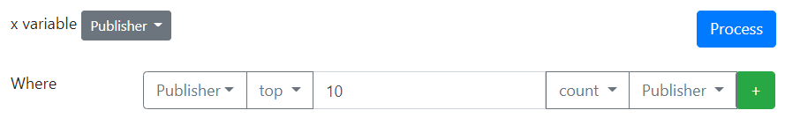

Figure 2-4 Dynamic Input

As we conclude, Nintendo has generated the most sales among the years in the previous graph, but we think about a question, is it the case that Nintendo generated many games so generated more sales? Hence, we constructed a donut chart to count the number of games under each of the publishers. As we can see from the donut chart, Nintendo is the runner up. In the donut chart, it shows the Nintendo and electronic arts have generated 296 and 341 games respectively.

Furthermore, as we obtained Nintendo and Electronic Arts are the most popular consoles among the years. Therefore, we further investigate which of the games are the most popular from each of the consoles by plotting a word cloud as shown in Figure 2-5 and Figure 2-7 below.

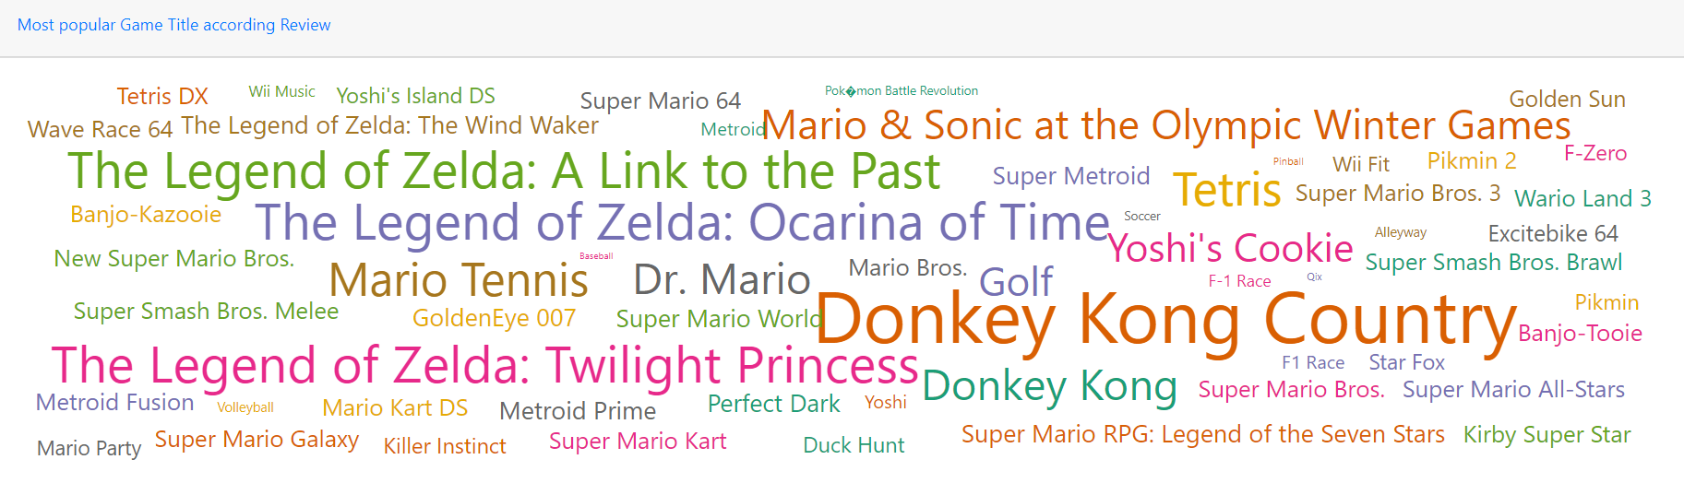

Figure 2-5 Games of Nintendo



Figure 2-6 Dynamic Input

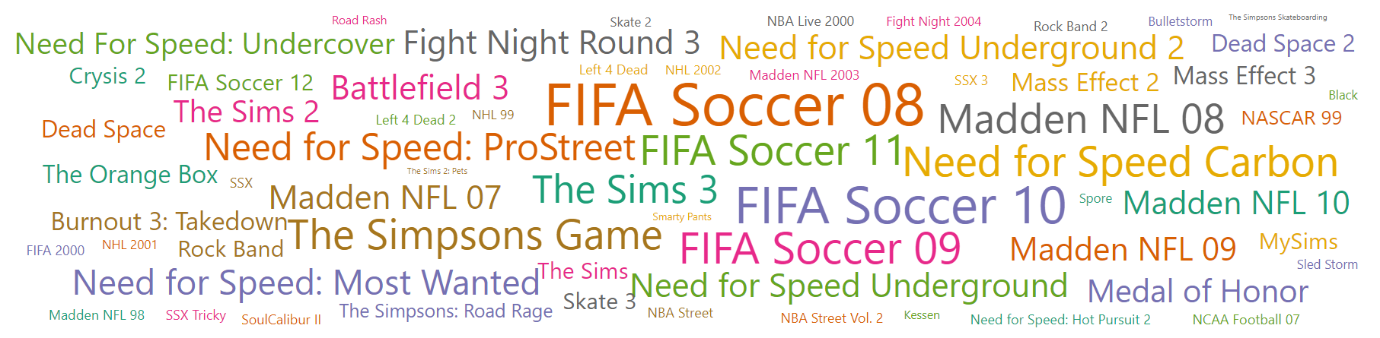

Figure 2-7 Games of Electronic Arts

In Figure 2-6, we investigate The Legend of Zelda and Donkey Kong Country as the most popular games from Nintendo. Besides, the Mario theme games also played an important role in the Nintendo as the frequency of the Mario theme games are the most.

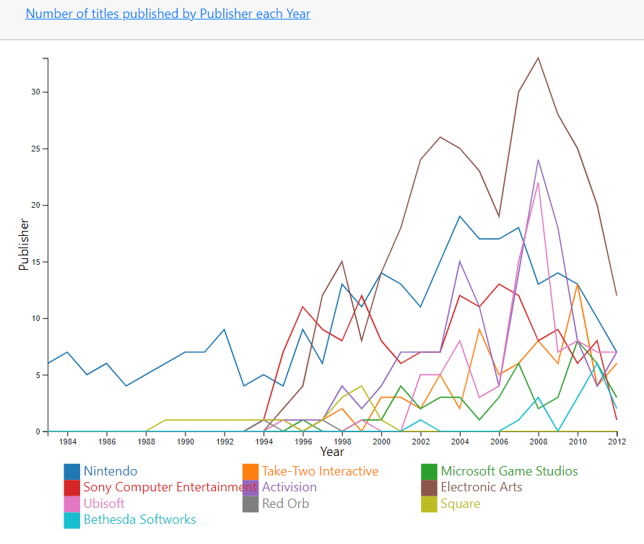

Figure 2-8 Number of titles published by Publisher each year

After analyzing the publisher details, we will determine the trends of the publishers by line chart. The reason we propose line charts in this graph is because of a time-series manner which the x-axis is the year and the y is the number of titles by the publishers. From this line chart, we obtain that although Nintendo is not the top but it is the one which started from 1984 until now 2021.

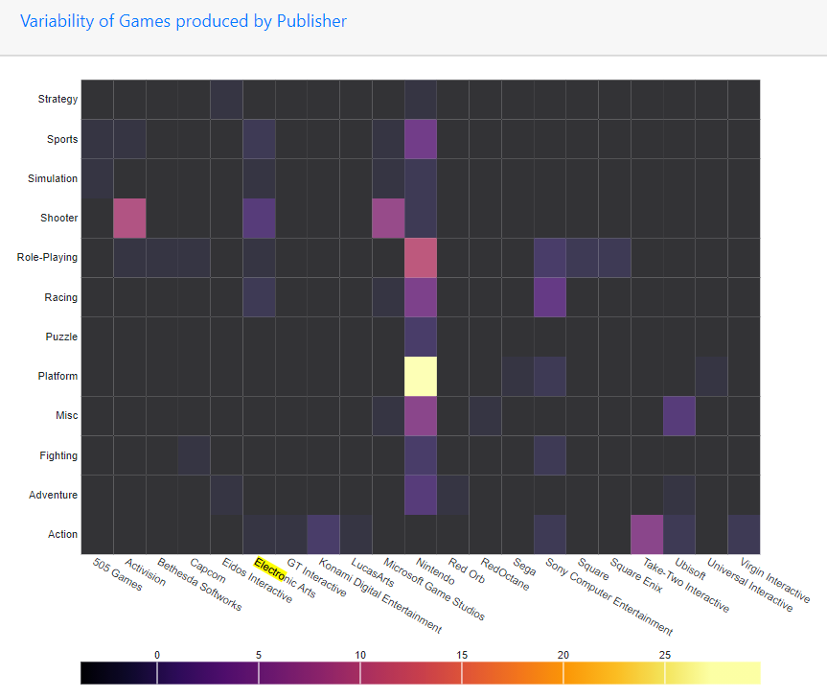

Figure 2-9 Variability of Games produced by Publisher

After that, we analyse what the genre of the games are and the publisher focuses on by plotting a heatmap shown in Figure 2-9. As we can see most genres are being focused by Nintendo meanwhile Electronic Arts only focus on Racing, Shooting and Sports.

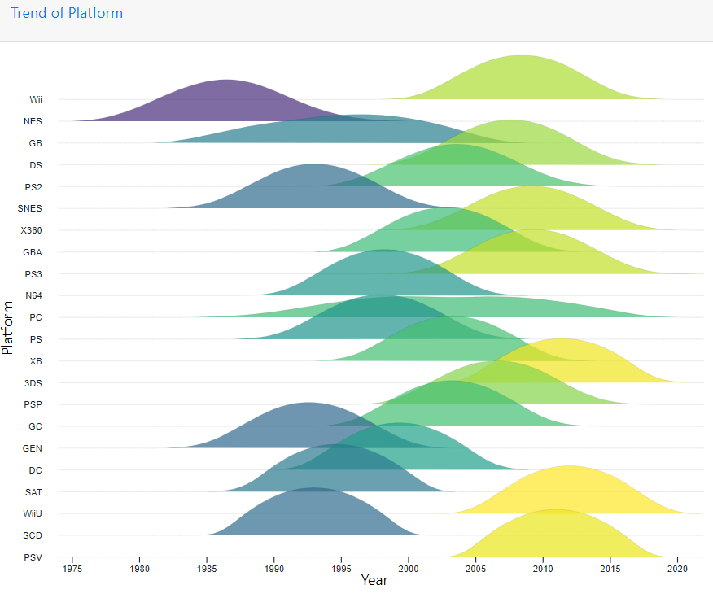

Figure 2-10 Trend of Platform

After analyzing the publishers, we further investigate which platform is having the longest lifetime. From the graph shown in Figure 2-10, we obtain that the PC is the one who is having the longest life time over the years.

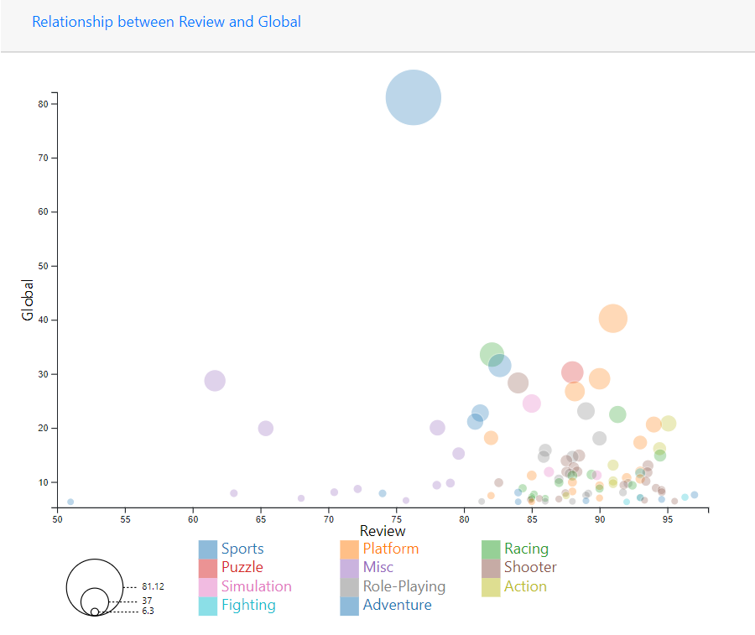

Figure 2-11 Relationship between Review and Global

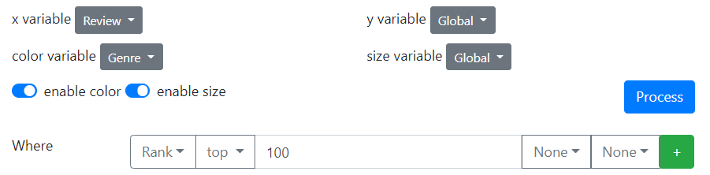

Figure 2-12 Dynamic Input

For this scatter plot, it is very helpful for us to investigate which of the regions tend to be more attractive to the particular genre of games. We used the size to determine the interest among the regions.

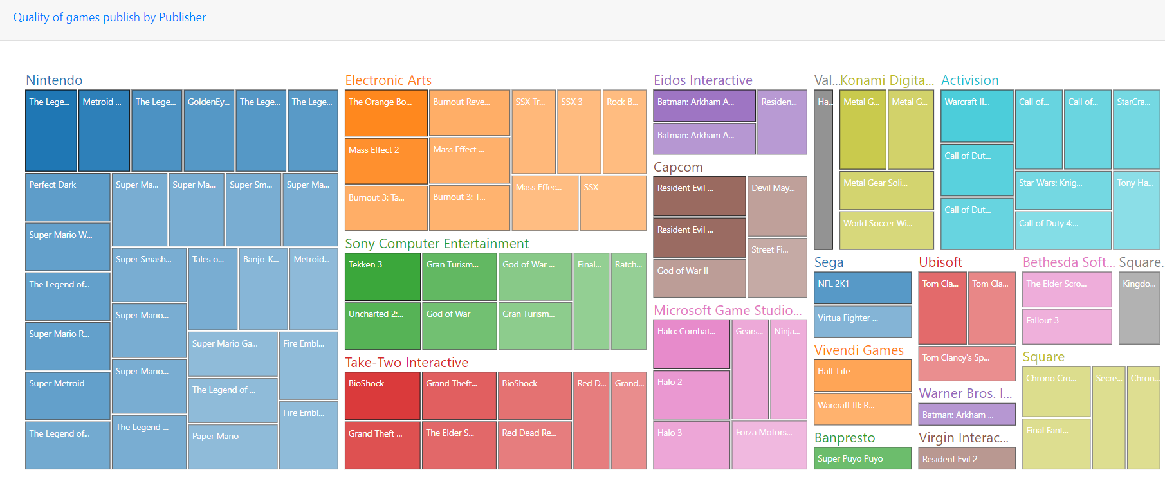

Figure 2-11 Quality of games publish by Publisher

As we know that Nintendo generates the most sales, produces many of the games, genre of games Nintendo focuses on and the how is the Nintendo trend over years, we can conclude Nintendo is the most successful publishers among the years. In the Figure 2-11, we have given the Top 100 games from each of the publishers can Nintendo take the largest ratio compared to others so it is hard to argue against our proof which we mentioned Nintendo is the most successful publisher.

# Explanation of changes in the implementation

We made some of the changes to our proposal. First and foremost, we had removed the boxplot, pie chart and added the new graphs which are donut chart, heatmap, rigidline in our final implementations. Besides, as we mention we will separate the dashboard in proposal, but we make it as a feature in our final dashboard which we allow the user to insert the dynamic input in order to study more results from the graphs by giving its dynamic inputs.

In a simple word, we have listed below and explain the purpose of each chart as well as why we had changed some of these.

* Pie Chart is replaced with the Donut Chart that has more potential of showing the frequency counts of the publishers. From our studies, we knew that the pie chart might lead some issues when showing the truth data. Hence, we have replaced it with donut chart and make a tooltip to it in order to show the frequency when hovering
* Boxplot is replaced with rigidline. For our case, after we deeply studied the dataset, there is no point for us to see the pricing. Hence the rigidline can help us to see the deeper trend of the platform over the years.
* For some of the graph we are allowed it to accept the dynamic input and the hovering to show data. The reason we did this method in this way is to allow the user to do more intended analysis and have the interaction between themselves with the graphs we constructed.

# Development Process

* Lee Wang Lin mainly focuses on doing Treemap, Heatmap and Rigid Chart.
* Cheok Jia Heng mainly focuses on doing Stacked Bar Chart and Pie Chart.
* Lee Xi Jie mainly focuses on doing Scatter Plot and Line Chart.
* We spent an estimate of
  + 1 hour looking for the data
  + 2 hours to understanding the data
  + 4 hours to prepare the proposal to be submitted
* After getting approved from Lecturer, Dr Noramiza. We separate the chart for the project
* We take 3 days to finish the chart that we assigned to ourself
* After the 3 days, we spent 6 hours meeting and discussing our chart. For example, which of the parts that we need to update.
* After finalizing our chart, we take another 8 hours to do the combining of all the charts
* 8 hours for filters and the CSS styling for the dashboard
* Approximately 3 days and 22 hours spent on building the final dashboard
* The most hardest part for us to finish this project is the combining the dashboard and the css styling.

# Reference

[1] [Video Games Sales](https://data.world/bramwax/video-games-sales/workspace/file?filename=Video+Games+Sales.xlsx)

[2] [10 Golden Rules of Data Visualization](https://www.dbta.com/BigDataQuarterly/Articles/10-Golden-Rules-of-Data-Visualization-114796.aspx)

[3] [Data Visualization Rules to Keep You Ahead of The Game](https://towardsdatascience.com/data-visualization-rules-to-keep-you-ahead-of-the-game-82c4b35ad22c)

[4] [5 Rules for Clarity in Data Visualization](https://www.monterail.com/blog/rules-of-data-visualization)